*Billy Feunang*

*Vaibhav Pathak*

*Lasha Khubashvili*

*Athea Jules*

**SMART CITIES**

Professeur : Christian Ghiaus



*https://www.futuribles.com/la-smart-city-mythe-et-realite/*

1. *Model*

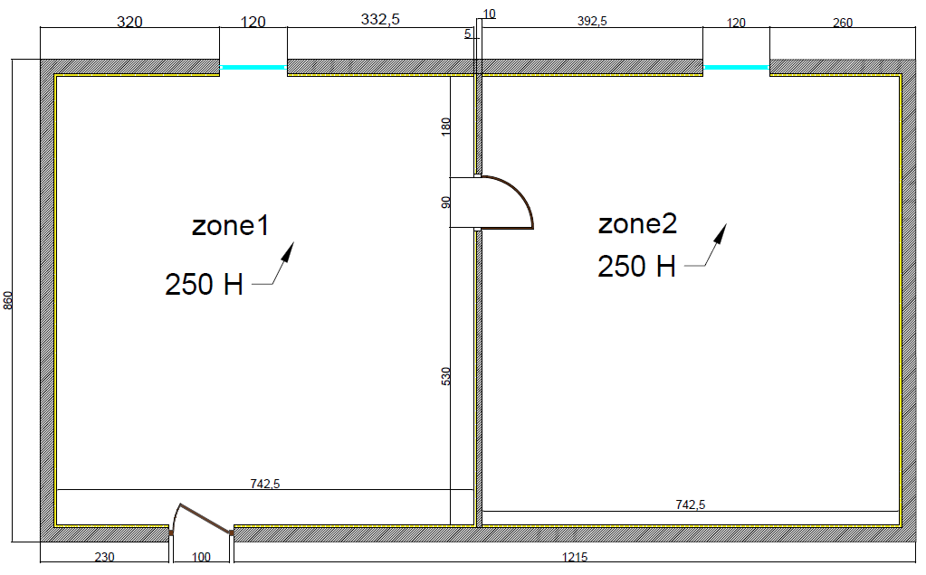

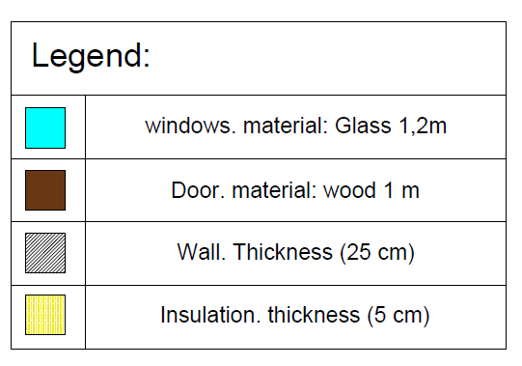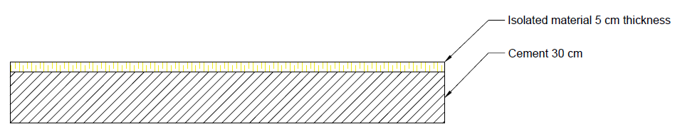

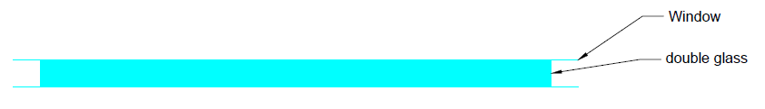

1. *Hypothesis:*

* *Uniform surface temperature on each wall.*
* *one dimensional heat transfer in each wall.*
* *Diffuse distribution of solar radiation within rooms.*
* 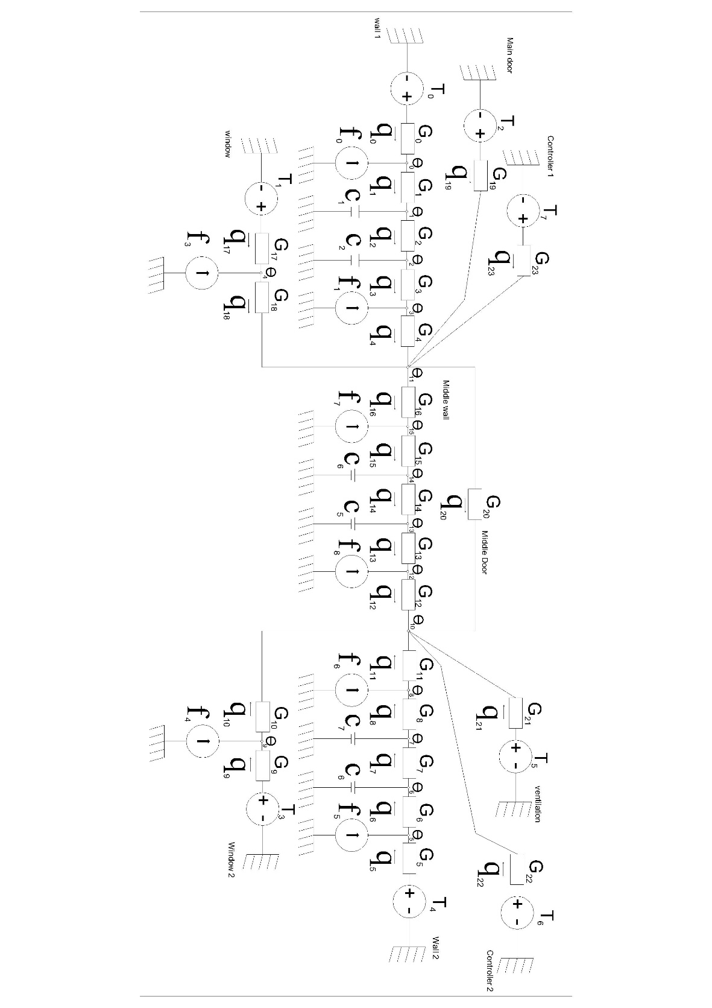*No heat transferred from ceilings.*

1. *Thermal circuit*
2. *Choice of the material*

*The wall is composed of two materials: concrete and insulation. The window is double glazing, and the door is made up of wood. The thermal properties of the materials are given as follow:*

|  |  |  |  |  |  |
| --- | --- | --- | --- | --- | --- |
|  | *Conductivity*  *W/mK* | *Density*  *Kg/m3* | *Specific heat*  *J/(Kg.K)* | *width* | *Surface* |
| *Concrete* | *1.400* | *2300* | *880* | *0.25* |  |
| *Internal concrete* | *1.400* | *2300* | *880* | *0.25* |  |
| *Internal Insulation* | *0.040* | *16* | *1210* | *0.05* |  |
| *Glass* | *1.400* | *2500* | *1210* | *0.04* |  |
| *Wood* | *0.2* | *2500* | *720* | *0.05* |  |
| *Air* |  | *1.2* | *1000* |  |  |

*Surface computations:*

*Surface1 (wall1) = 3.2m*2.5m + 3.32m*2.5m = 16.3 m2*

*Surface2 (wall2) = 3.92m*2.5m + 2.6m*2.5m = 16.3 m2*

*Surface3 (indoor wall) = 5.30m*2.5m + 1.8m*2.5m = 17.75 m2*

*Surface glass (window) = 1.2m*2.5m = 3 m2*

*Surface of the insulation 1 = 2.95m*2.5m + 3.32m*2.5m = 15.7 m2*

*Surface of the insulation 2= 3.92m*2.5m + 2.35m*2.5m = 15.7 m2*

*Surface of the insulation (indoor insulation) = 1.2m*2.5m = 3 m2*

*Data:*

* Thermal conduction (conduction): G=(conductivity*Surface)/width
* Thermal conduction (convection): G=1/(convection coefficient*Surface)
* Thermal capacity: C=density*specific heat cap.*width*surface

|  |  |  |
| --- | --- | --- |
| *Parameters* | *Conductance* | *Thermal capacities* |
| *G* |  |  |
| *G* |  |  |
| *G* |  |  |

1. Computation of the thermal conductance for conduction, convection, long-wave radiation, and advection.

Matrix A=

[ 1. 0. 0. 0. 0. 0. 0. 0. 0. 0. 0. 0. 0. 0. 0. 0.]

[-1. 1. 0. 0. 0. 0. 0. 0. 0. 0. 0. 0. 0. 0. 0. 0.]

[ 0. -1. 1. 0. 0. 0. 0. 0. 0. 0. 0. 0. 0. 0. 0. 0.]

[ 0. 0. -1. 1. 0. 0. 0. 0. 0. 0. 0. 0. 0. 0. 0. 0.]

[ 0. 0. 0. -1. 0. 0. 0. 0. 0. 0. 0. 1. 0. 0. 0. 0.]

[ 0. 0. 0. 0. 0. 1. 0. 0. 0. 0. 0. 0. 0. 0. 0. 0.]

[ 0. 0. 0. 0. 0. -1. 1. 0. 0. 0. 0. 0. 0. 0. 0. 0.]

[ 0. 0. 0. 0. 0. 0. -1. 1. 0. 0. 0. 0. 0. 0. 0. 0.]

[ 0. 0. 0. 0. 0. 0. 0. -1. 1. 0. 0. 0. 0. 0. 0. 0.]

[ 0. 0. 0. 0. 0. 0. 0. 0. 0. 1. 0. 0. 0. 0. 0. 0.]

[ 0. 0. 0. 0. 0. 0. 0. 0. 0. -1. 1. 0. 0. 0. 0. 0.]

[ 0. 0. 0. 0. 0. 0. 0. 0. -1. 0. 1. 0. 0. 0. 0. 0.]

[ 0. 0. 0. 0. 0. 0. 0. 0. 0. 0. -1. 0. 1. 0. 0. 0.]

[ 0. 0. 0. 0. 0. 0. 0. 0. 0. 0. 0. 0. -1. 1. 0. 0.]

[ 0. 0. 0. 0. 0. 0. 0. 0. 0. 0. 0. 0. 0. -1. 1. 0.]

[ 0. 0. 0. 0. 0. 0. 0. 0. 0. 0. 0. 0. 0. 0. -1. 1.]

[ 0. 0. 0. 0. 0. 0. 0. 0. 0. 0. 0. 1. 0. 0. 0. -1.]

[ 0. 0. 0. 0. 1. 0. 0. 0. 0. 0. 0. 0. 0. 0. 0. 0.]

[ 0. 0. 0. 0. 0. -1. 0. 0. 0. 0. 0. 1. 0. 0. 0. 0.]

[ 0. 0. 0. 0. 0. 0. 0. 0. 0. 0. 0. 1. 0. 0. 0. 0.]

[ 0. 0. 0. 0. 0. 0. 0. 0. 0. 0. -1. 1. 0. 0. 0. 0.]

[ 0. 0. 0. 0. 0. 0. 0. 0. 0. 0. 1. 0. 0. 0. 0. 0.]

[ 0. 0. 0. 0. 0. 0. 0. 0. 0. 0. 1. 0. 0. 0. 0. 0.]

[ 0. 0. 0. 0. 0. 0. 0. 0. 0. 0. 0. 1. 0. 0. 0. 0.]]

